SMITH-ATLAS AWARD SETUP ASSISTANT
SA-1012-V1

Table of Contents

I. About 1
II. User Guide 2
III. One-Time AI Agent Setup Instructions 6
1. Name 6
2. Description 6
3. Instructions 6
4. Knowledge 6

About

Version | SA-1012-V1
Release Date | October 14, 2026
Developer(s) | Matt G. Smith
Contact Information | matt@smith-atlas.com
Short Description | Extracts 52 award administration data elements from executed grants, cooperative agreements, contracts, and their amendments to support award setup or understanding key elements of the award, as amended. Produces a cited abstract that consolidates the current data elements and key terms and conditions, plus a summary of what each amendment changed. Output is available as a Word document, a system-neutral CSV file, or both.
AI Solution & Model | The system instructions are designed to be AI tool agnostic—meaning that Gemini, Claude, ChatGPT, Copilot, and in-house solution, etc., users can implement these system instructions in their Gems, Projects, GPTs, Agents, and Assistants, respectively.
Licensing | MIT License.

User Guide

- Open your AI agent titled “SMITH-ATLAS AWARD SETUP ASSISTANT (SA-1012-V1).”

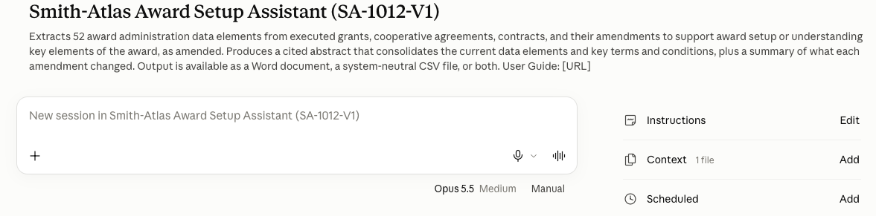

- Copy and paste the following blue font prompt into your AI agent’s chat area:

Please prepare a complete award abstract for setting up this award in our research administration system. Attached are the fully executed agreement and any amendments. If there are amendments, show the current conformed terms and what each amendment changed. Output format: [Choose “Word”, “CSV”, or “Both”]

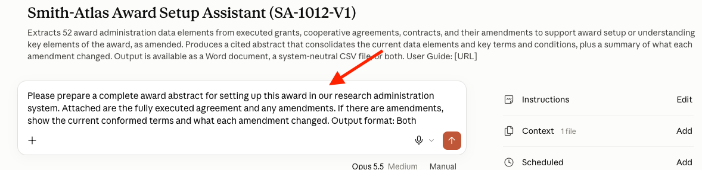

- Change your AI model to a capable model.

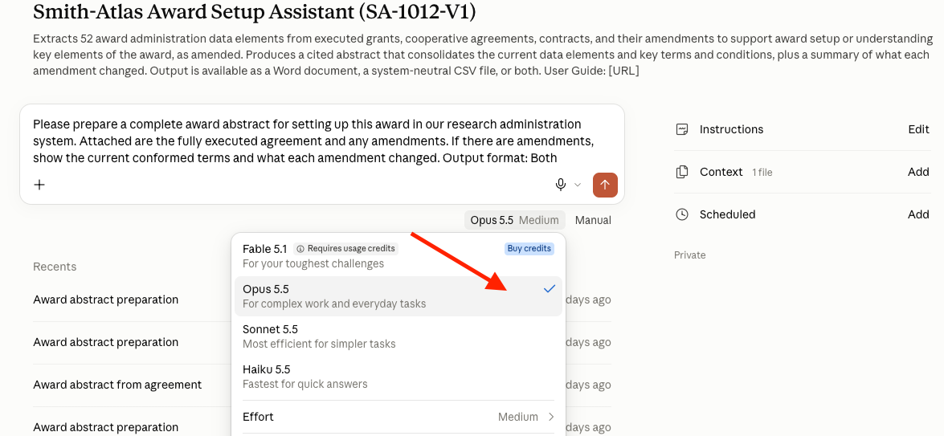

- Upload a PDF copy of the award and any amendments from which you’d like to extract information for award setup (or for a summary snapshot describing key data elements of the award, as amended).

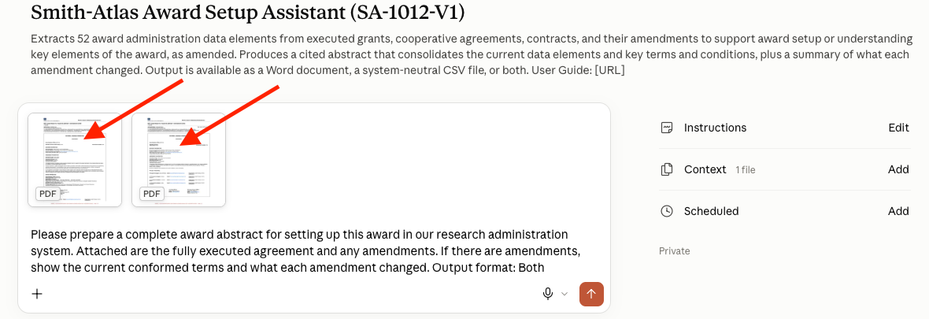

- Press “Enter” on your keyboard or click “Submit,” “Send Message,” or a similar approach on your AI agent chat interface.

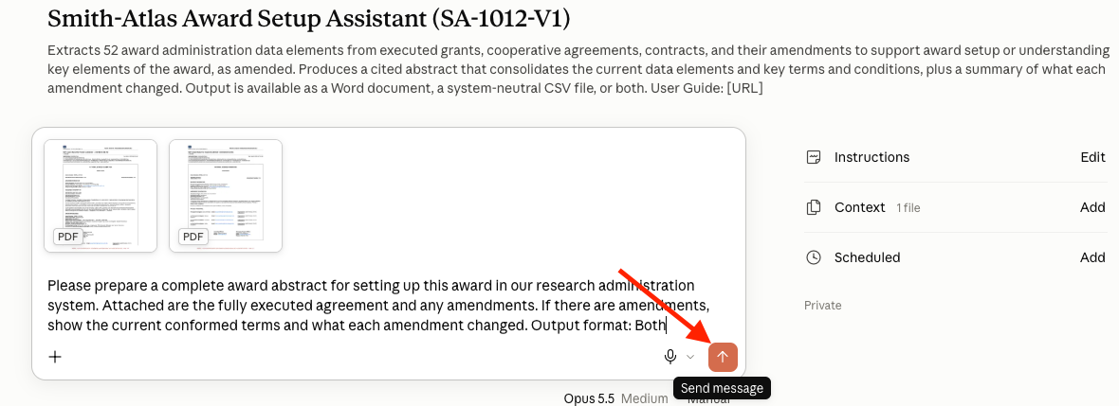

- After the AI agent has completed its work, download the output.

  - Word: The Microsoft Word output will look like the following. It is useful for manual award setup in your research administration system, as well as for understanding key data elements from an award as amended (e.g., for troubleshooting an issue).

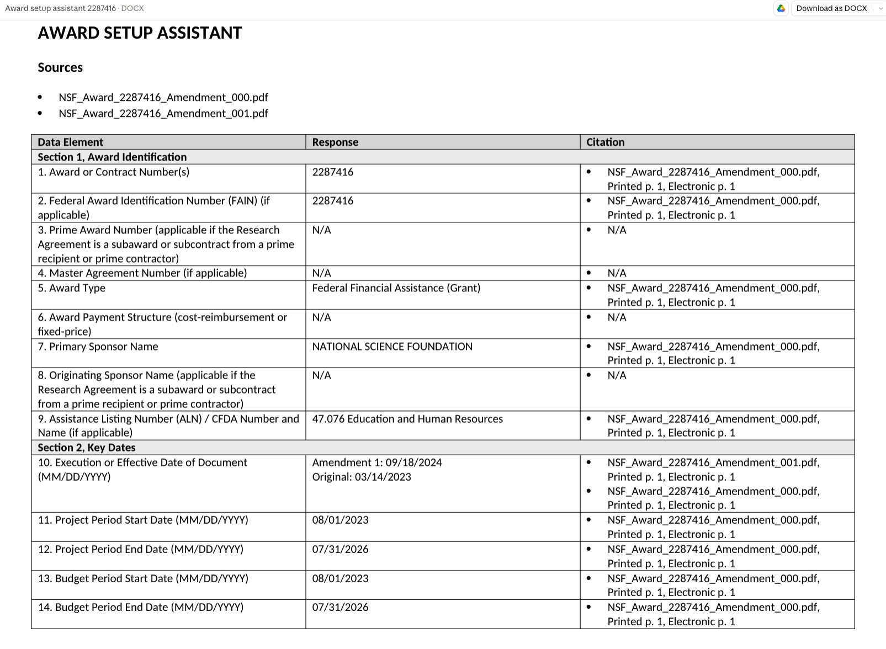

  - CSV: The CSV output will look like the following. It is useful for middleware integrations with research administration systems (i.e., to enter the draft data elements into a research administration system for internal review before posting).

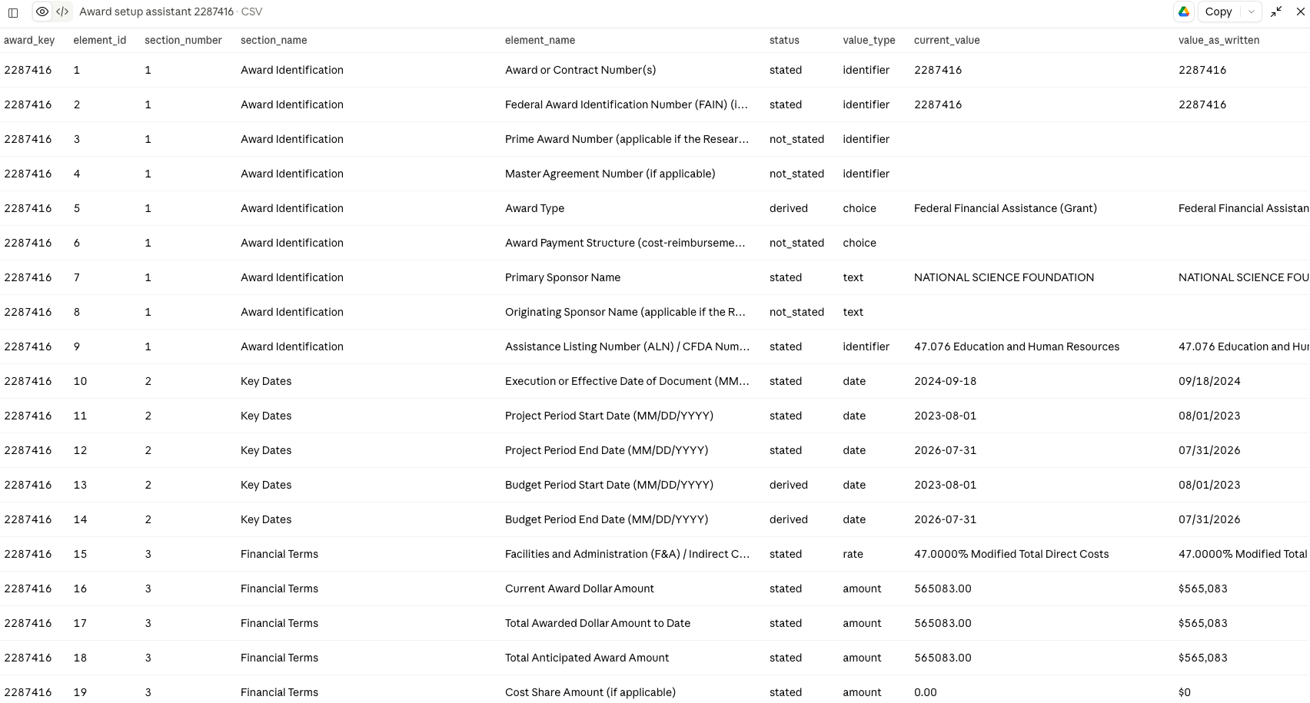

- End instructions.

One-Time AI Agent Setup Instructions

Name

Copy and paste the following text into your AI agent’s name field:

Smith-Atlas Award Setup Assistant (SA-1012-V1)

Description

Copy and paste the following text into your AI agent’s description field (making sure to add a link to your user guide, which could be a revision of this document):

Extracts 52 award administration data elements from executed grants, cooperative agreements, contracts, and their amendments to support award setup or understanding key elements of the award, as amended. Produces a cited abstract that consolidates the current data elements and key terms and conditions, plus a summary of what each amendment changed. Output is available as a Word document, a system-neutral CSV file, or both. User Guide: [URL]

Instructions

Copy all of the system instructions from the Loader.txt file and paste them into your AI agent’s instructions field.

Knowledge

Upload the Process.txt file into the AI agent’s internal knowledge using the exact file name.

